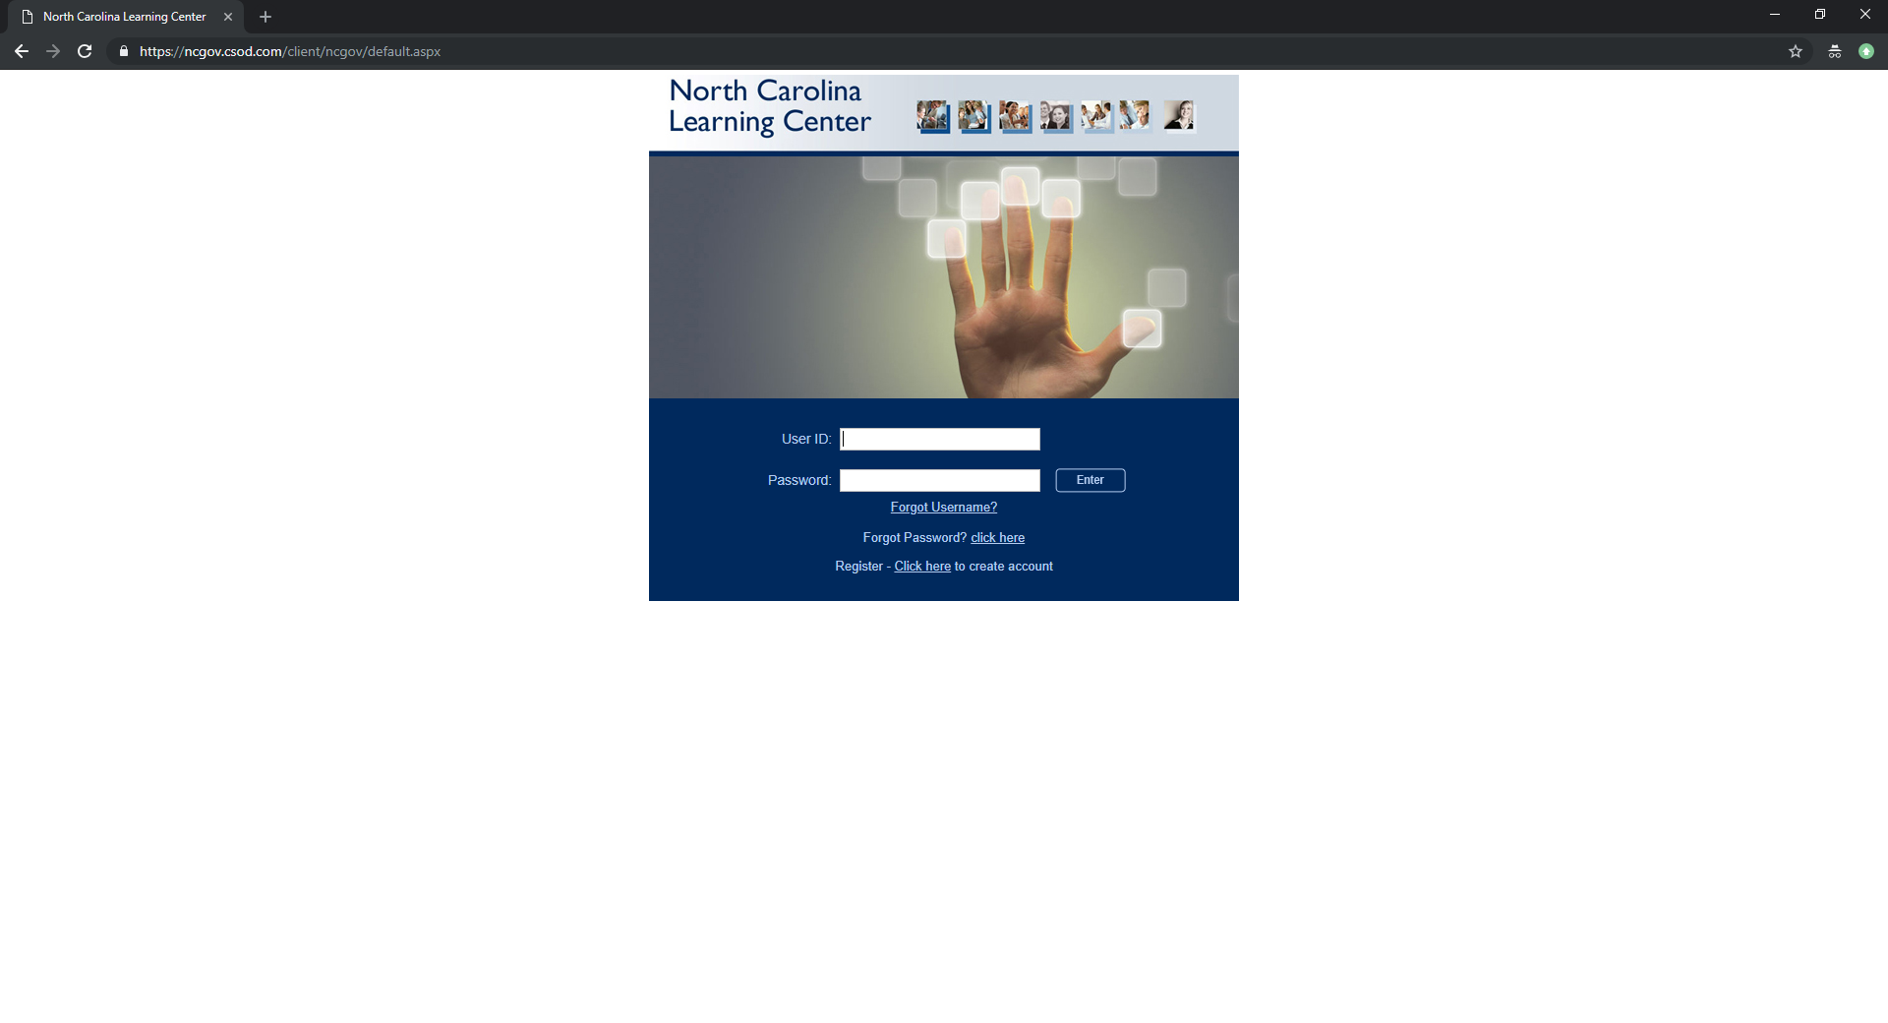
PROBLEM: When attempting to launch training modules from ncgov.csod.com in Google Chrome, content won’t load due to Flash Player requiring approval to run. To correct this, Flash must be allowed to run for the site ncgov.csod.com.

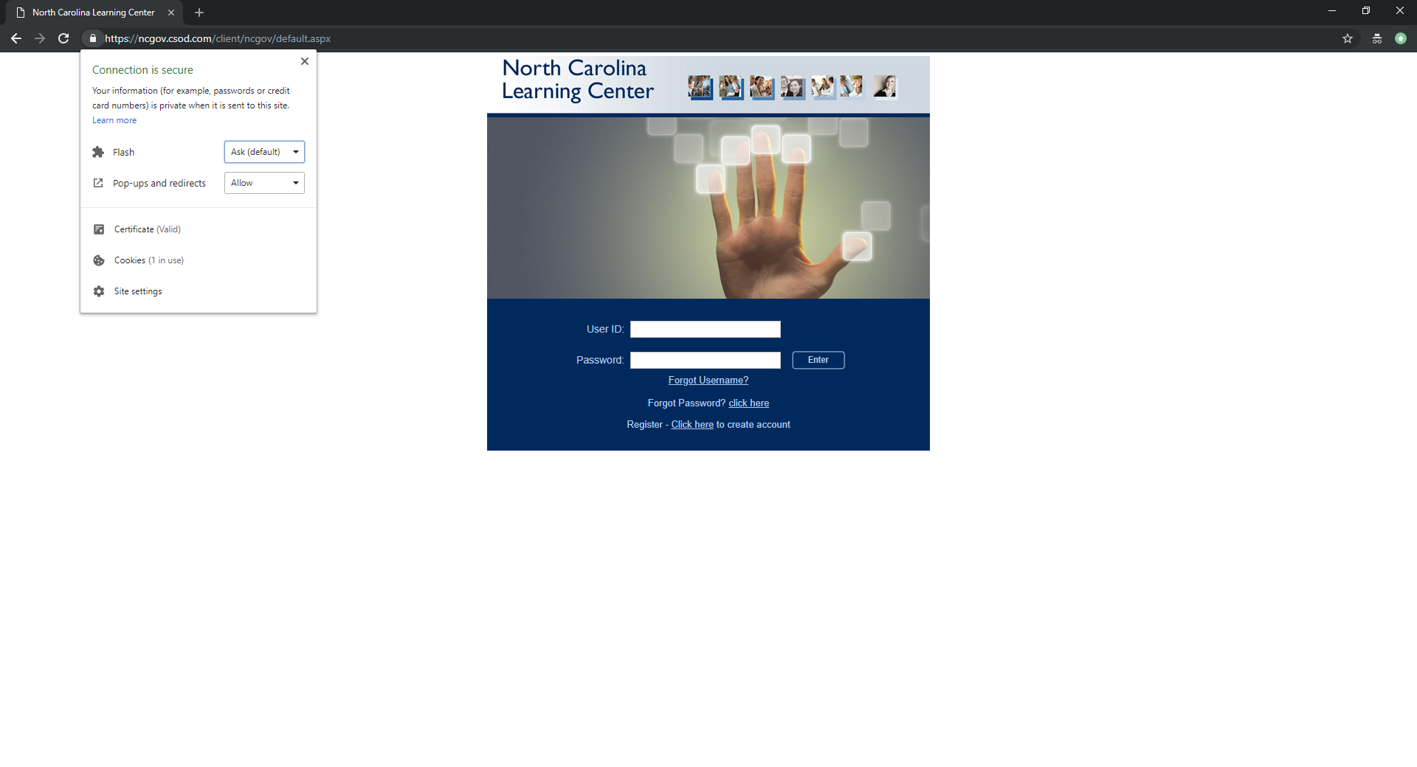
- To bypass this, click the lock icon to the left of the address bar, and a popup window will display security options for the site.
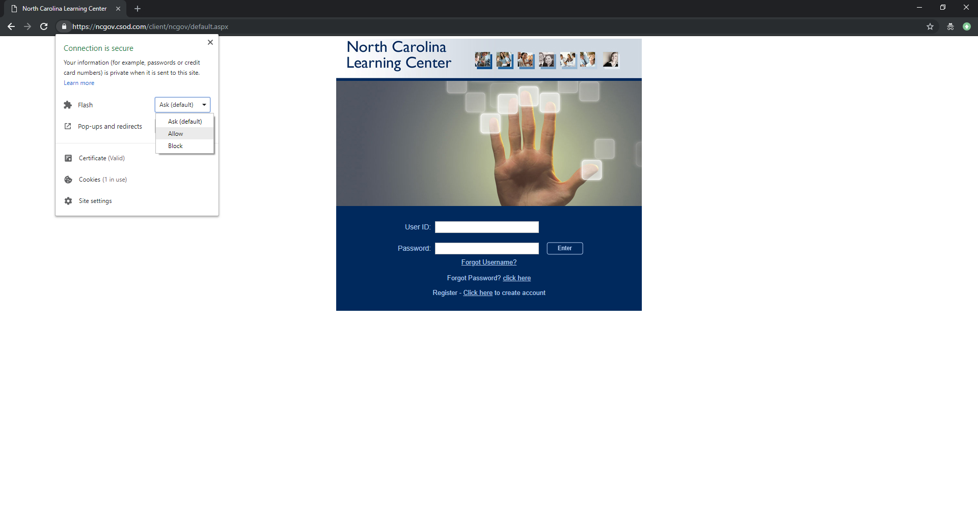
- Change the option for Flash from Ask (default) to Allow.

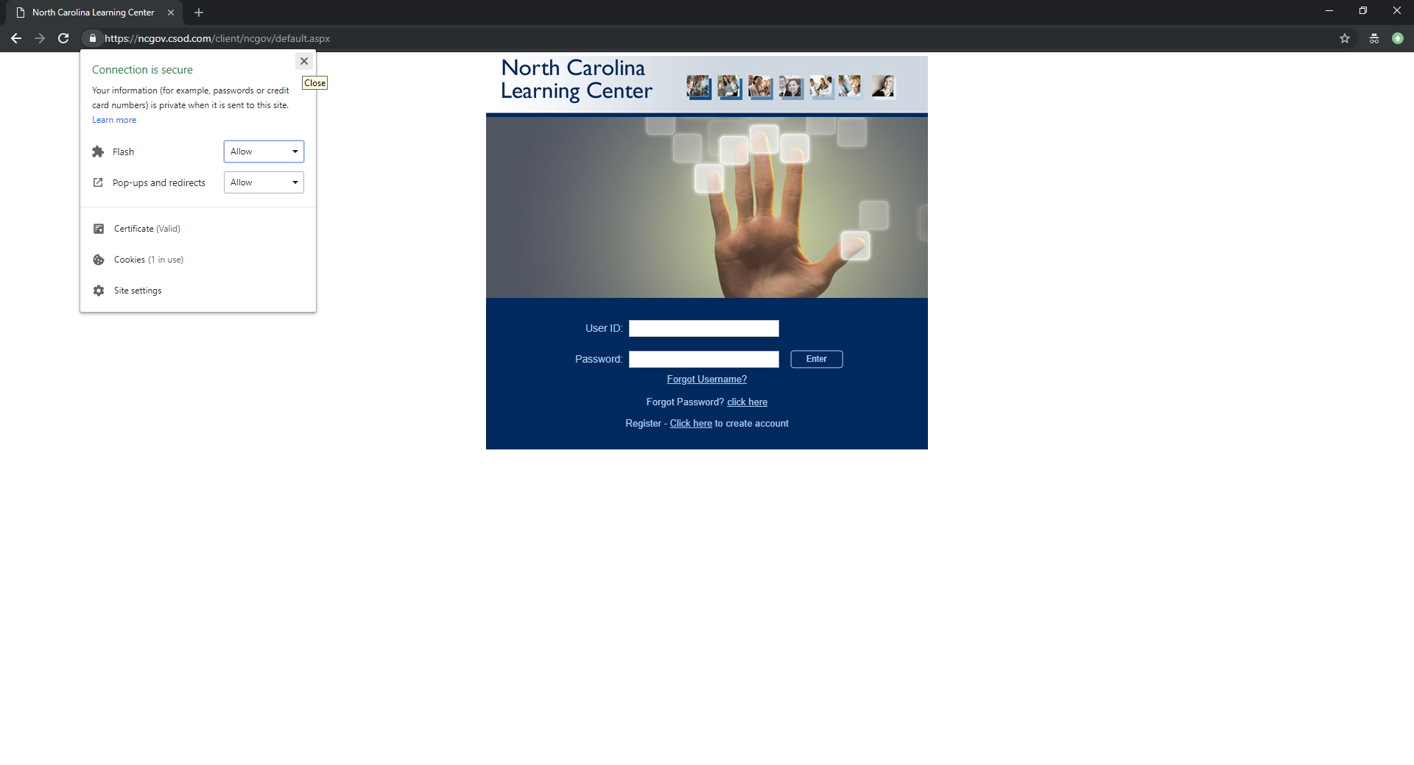
- Click the X in the upper-right hand corner of the Security popup (not the training window) to close the settings popup.
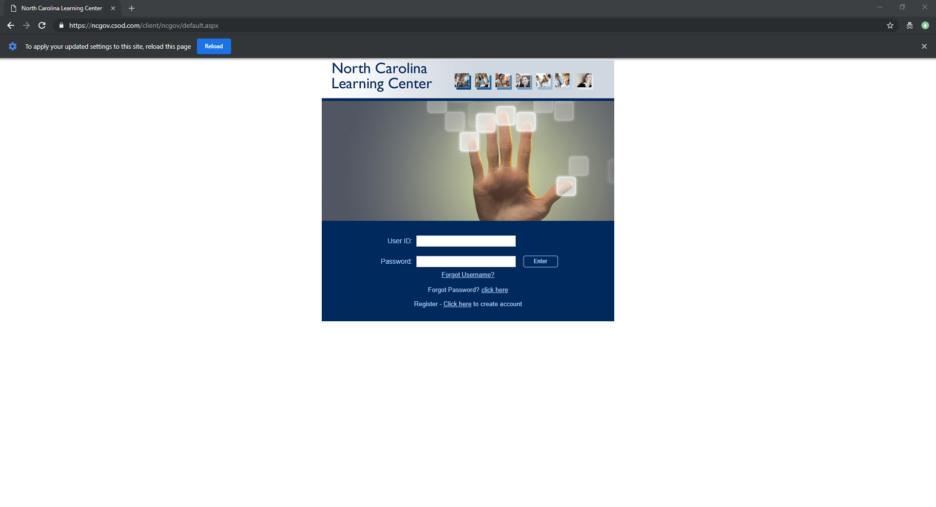
- Click the Reload button at the top of the screen.

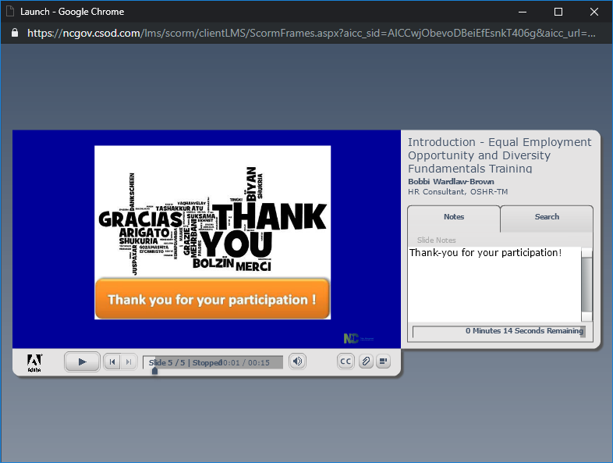
- Content will now load as expected.

In some cases, the Flash option doesn’t show in the site security dialog box. If this is the case, follow these instructions:
- Click the lock icon to the left of the address bar, and a popup window will display security options for the site.
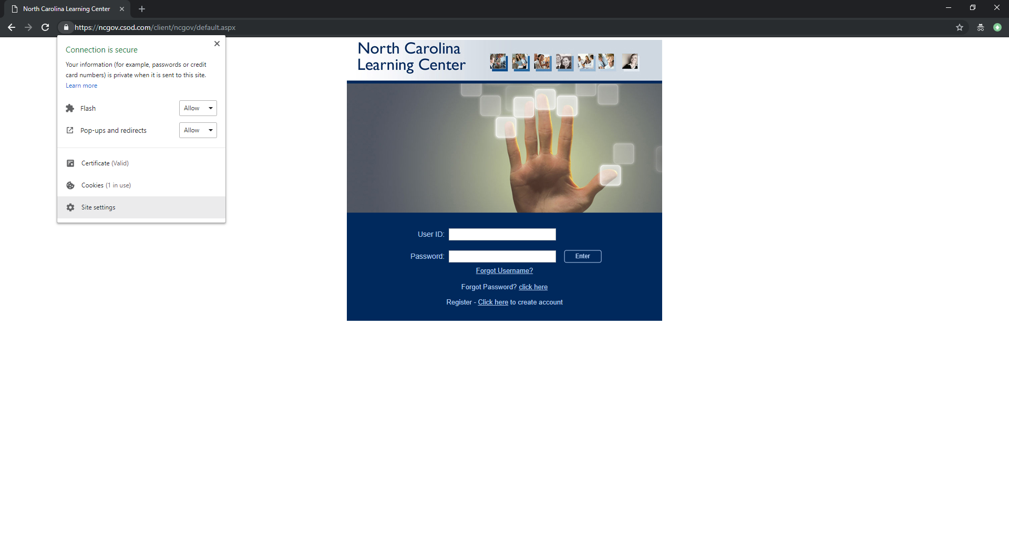
- Click the Site settings option at the bottom of the dialog box.

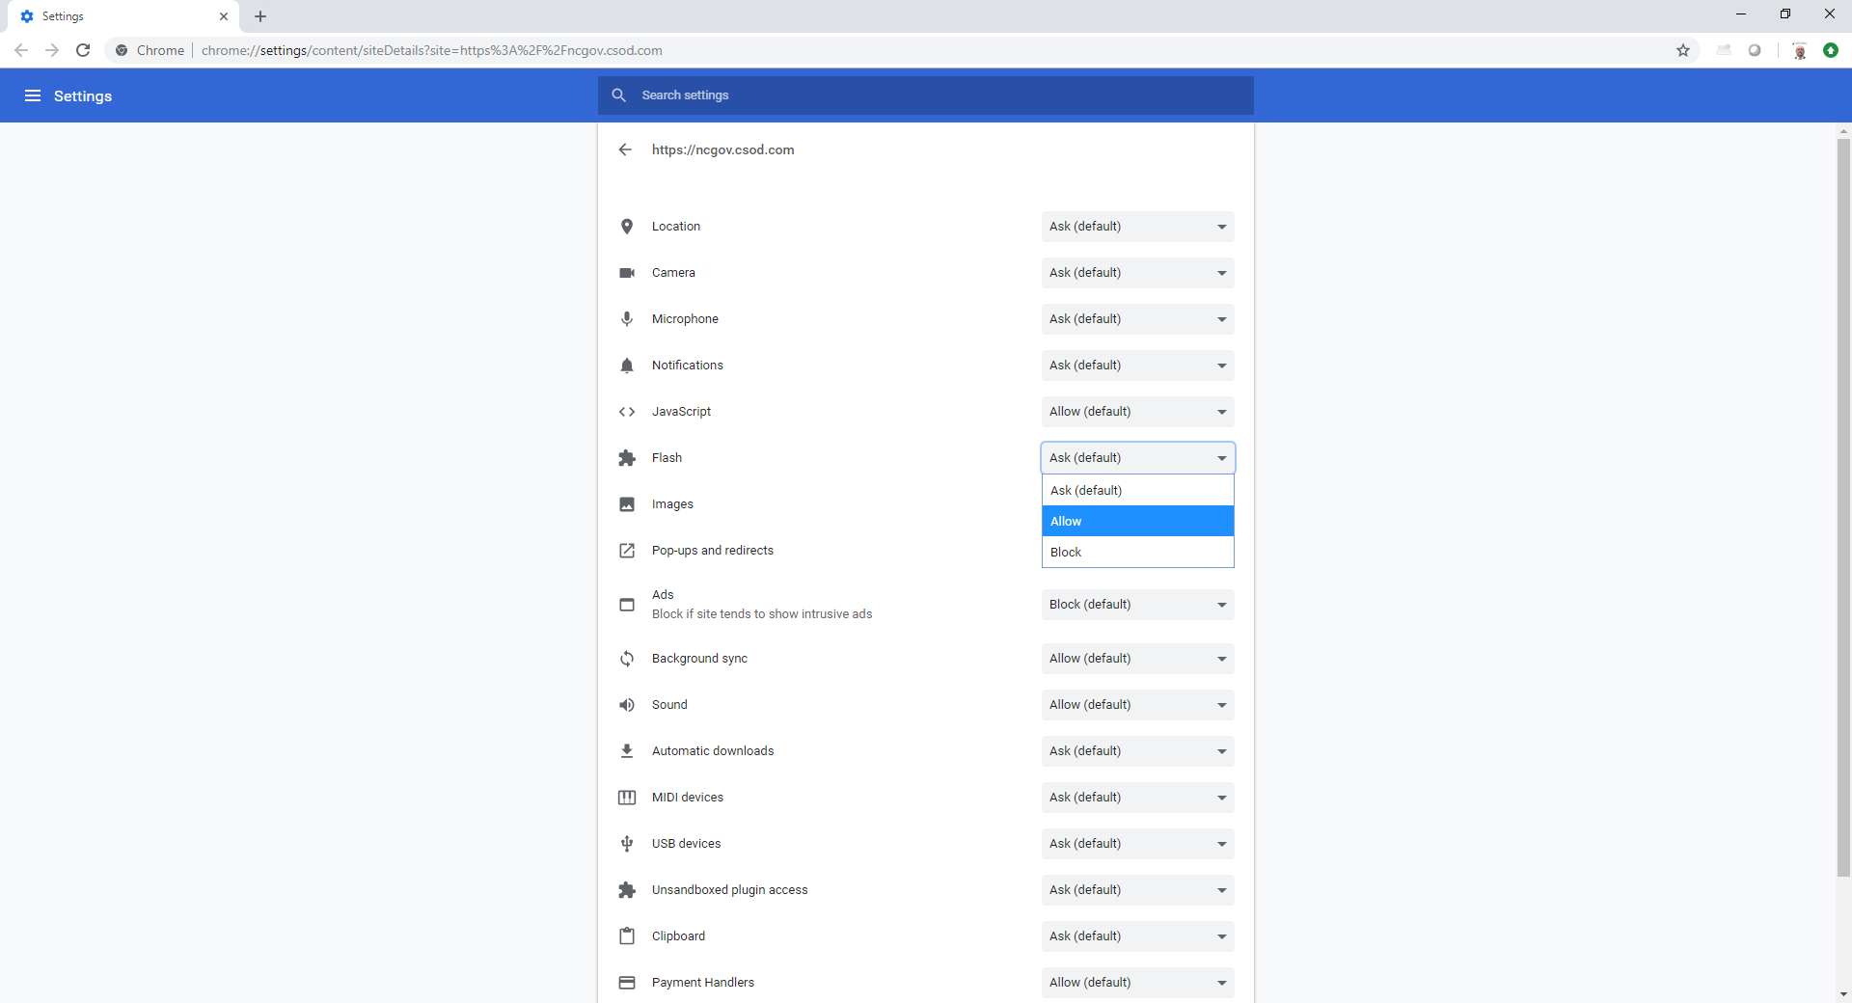
- In the new Settings tab, change the option for Flash from Ask (default) to Allow. Close the Settings tab.
- Click the Reload button at the top of the screen.
- Content will now load as expected.

