Part 1. Standards for Organizational Charts
Organizational Charts shows the structure of an organization and the relationships and relative ranks of its positions. To ensure consistency, organizational charts at UNCG should follow the guidelines as outlined in this document.

CREATING AN ORGANIZATIONAL CHART
Identifying information should be included in the upper left corner of the chart stating:
- University Name
- Division Name
- Department/College Name (Not required if you do not work in a department/college such as Business Affairs, Chancellor’s Office, etc.)
- Date Prepared
Example: | University of North Carolina at Greensboro
 | Academic Affairs
 | Bryan School of Business and Economics
 | January 2017

Each position on the organizational chart should be identified by:
- Position Number
- Employee’s Name
- Title
- SHRA or EHRA
- Contributing, Journey, or Advanced (if SHRA)

Example: | 009999
 | Jane Doe
 | Student Services Specialist
 | SHRA
 | J

Multiple positions of the same classification reporting to the same supervisor can be combined in one box.

Example: | 001116
 | John Doe
 | Building and Environmental Supervisor
 | SHRA
 | J
 | I
 | 001112 John Doe II Bldg Env Serv Tech SHRA C
 | 001113 John Doe III Bldg Env Serv Tech SHRA C
 | 001114 John Doe IV Bldg Env Serv Tech SHRA C
 | 001115 John Doe V Bldg Env Serv Tech SHRA C

Temporary positions and students should not be included on the organizational chart.

SUB-UNITS
Sub-units of departments may have their own organizational chart. This will help with departments that are very large. For example, the Department of Facilities has several sub-units including Housekeeping, Grounds, Maintenance, etc.

FORMATTING
- Must be printable on an 8 1/2" x 11" letter size sheet of paper
- Page orientation should be landscape
- Rectangle shapes should be used, other graphics or shapes should be avoided
- Must be formatted in plain black and white to ensure legibility
Part 2. Process for Maintaining UNC Greensboro Org Charts
UNCG Org Charts will be:
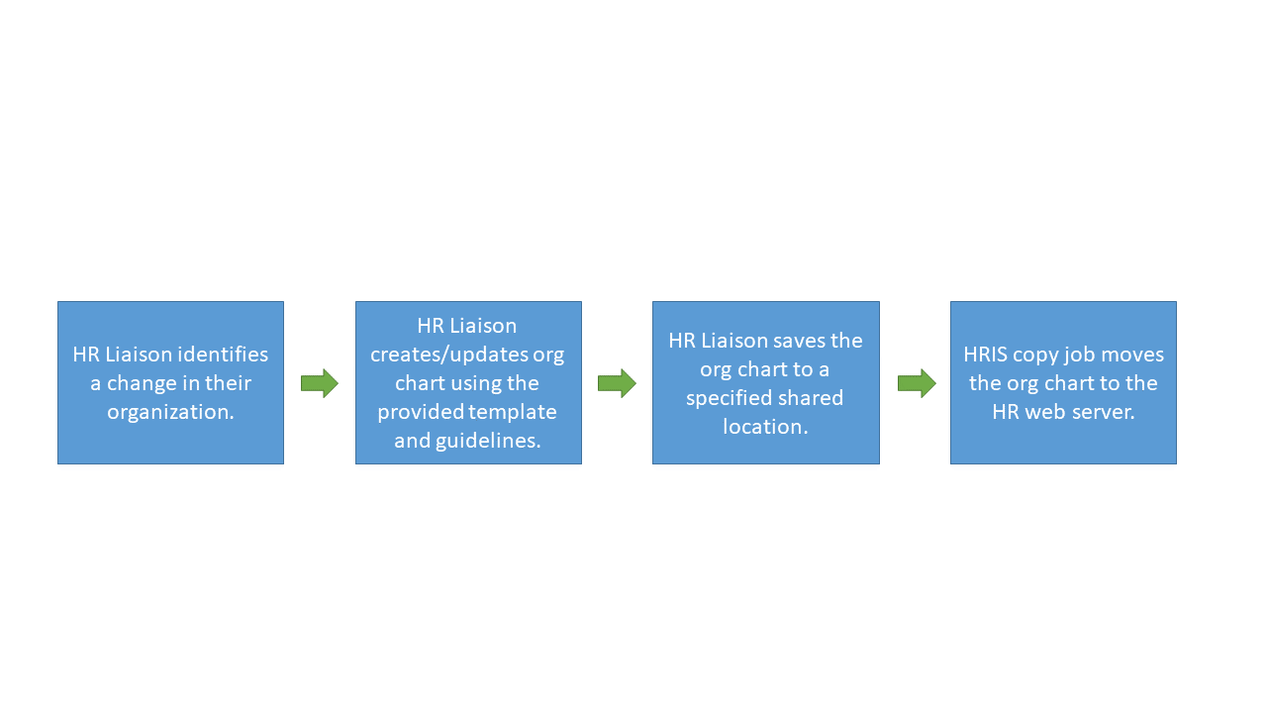
- Maintained by the HR Liaisons.
- Created using the UNC Greensboro Standards for Organizational Charts.
- Created using the provided power point template.
- Saved in pdf format.
- Named the department numerical code (For Example HR is: 58401.pdf).
- Placed in a specific server location (TBD).
- Housed on the HR web server.

