Process for Maintaining UNC Greensboro Org Charts
UNC Greensboro Org Charts will be:
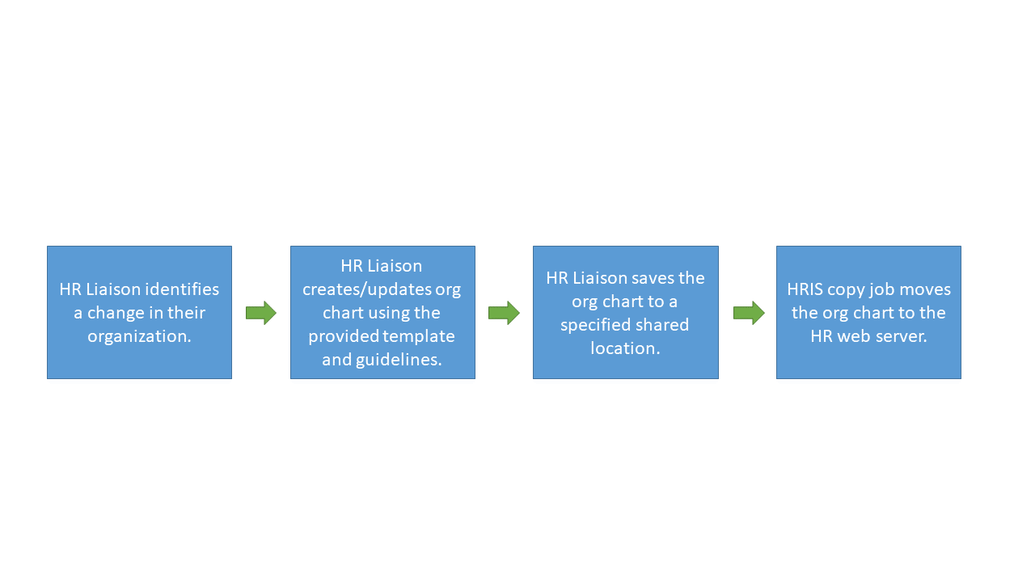
- Maintained by the HR Liaisons.
- Created using the UNC Greensboro Standards for Organizational Charts.
- Created using the provided power point template.
- Saved in pdf format.
- Named the department numerical code (For Example HR is: 58401.pdf).
- Placed in a specific server location (TBD).
- Housed on the HR web server.

